1. **Table of Content**

1.0Table of Content ……………………………………………………...1

2.0Description …………………………………………………………….2

2.1 Problem Definition

2.2 Background

2.3 Product Scope

2.4 Over View

2.5 Overall Description

2.6 Objectives and Goals

2.7 Intended Audience

3.0 Requirements ……….……………………………………………......4

3.1 Functional Requirements

3.2 Non-Functional Requirements

3.3 Hardware Requirements

3.4 Software Requirements

4.0 Methodology ………………………………………………………….6

5.0 Feasibility Study………………………………………………………7

5.1 Economical feasibility

5.2 Technical feasibility

5.3 Operational feasibility

6.0 Diagrams ……………………………………………………………...8

6.1 ER Diagrams

6.2 Use Case Diagrams

6.3 Class Diagrams

**2.0 Description**

**2.1 Problem Definition**

Since a service record of an employee is recorded in the books, one has to face problems in revising and updating. As some employees take several courses, information is recorded in several places. So it takes a lot of time to retrieve and update that information. In some cases, the accuracy of the information also poses a problem.

**2.2 Background**

Cooperative development department employs a large number of employees in the southern province. The information of their studied and currently studying courses is recorded in a book. The information is recorded by _ of this institution. The information recorded should be updated and reviewed periodically. It takes a lot of time, so the commissioner decided to set up a computer base recoding system as an alternative.

**2.3 Product Scope**

This **Employee Management System** is based on a relational database and it allows to record course details of Employe’s .Also that system can retrieve and update that employes cources data. Due to this system, time is saved and the confidentiality of information is protected.

**2.4 Over View**

To provide information about an employee's courses studied and currently studying. Sometimes that information needs to be reviewed and updated. Here the old information can be obtained from the ID number and it can also be updated.

As well as additional purposes,

* Add new cources.
* Print the customer details if needed
* Backup the database.

this system doing such things.

**2.5 Overall Description**

The Cooperative Development Department in the southern province manages a substantial workforce. The details of the educational backgrounds, including completed and ongoing courses, are traditionally maintained in physical record books by the department's personnel. However, the process of recording and periodically updating this information is time-consuming. Recognizing the inefficiency, the department's commissioner has made the decision to implement a computer-based recording system as a more efficient alternative.Since I am training there, the commissioner told me to give a solution to it.

**2.6 Intended Audience**

* **User**

Admin can access the administration module and the reports module. They are permitted to add new cources & new Employes, edit and update details. Moreover, they are also allowed to generate employee details reports.

* **Employee**

The employes not uses of this system. They are just intended in to this system Because user record Employees cources details using the system.

**3.0 Requirements**

**3.1 Functional Requirements**

* **Add Employes**

Entering an employee of the Cooperativa development department. And they are identified by their ID number.

* **Add Cources**

Entering the details of courses studied and currently being studied by an employee

* **Issue the printable document**

Where necessary, the course information of the employees should be taken in print form..

* **Retrive employe details**

Their information should be available through the employee's nic number

**3.2 Non-Functional Requirements**

* Interfaces should be user friendly.
* System should be fast.
* System should store data securely.
* Current date and time should be displayed.
* Unauthorized access should be prevented.

**3.3 Hardware Requirements**

* **CPU :** Intel i3 2.21 GHz
* **RAM :** 4GB
* **Space :** 3GB or more space on Hard drive
* **Monitor :** 1280*800 resolution or more

**3.4 Software Requirements**

* Windows 10 or above
* VB.net
* MS Access

**4.0 Methodology**

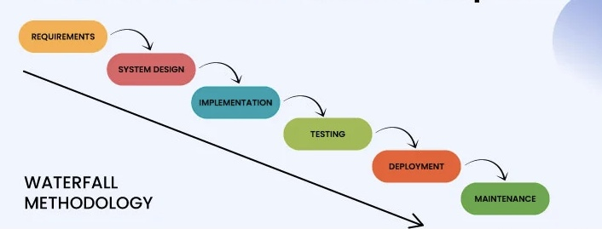

The Waterfall methodology is a traditional, linear approach to software development and project management. It is one of the earliest and most well-known software development methodologies. In the Waterfall model, a project is divided into distinct phases, and each phase must be completed before the next one begins. The phases typically include:.

1. Requirements Gathering: In this initial phase, all the project's requirements are gathered and documented.
2. System Design: Based on the gathered requirements, the system's architecture and design are planned.
3. Implementation (Coding): Developers start coding and implementing the system according to the design.
4. Testing: After the implementation, the system undergoes testing to ensure it meets the requirements and is free of defects.
5. Deployment: Once the system passes testing, it is deployed and released to users.
6. Maintenance: Ongoing maintenance and support activities are carried out as necessary.

The Waterfall methodology is characterized by its strict, linear progression from one phase to the next, and there is typically minimal flexibility to revisit previous phases once they are completed. It's a highly structured approach that works well for projects with well-defined requirements and when changes are costly or undesirable.

One of the main criticisms of the Waterfall model is its limited adaptability to changes in requirements that often occur during software development projects. This has led to the development of more flexible methodologies like Agile, which allow for iterative development and more frequent opportunities to adjust project requirements as needed.

**5.0 Feasibility Study**

A feasibility study, as the name suggests, is designed to reveal whether a project/plan is feasible. It is an assessment of the practicality of a proposed project/plan.

**5.1 Economical feasibility**

Receipt generation in the proposed system in precise that is Receipts are generated as per user requirements, which reduces the use of papers and manual labor.

**5.2 Technical feasibility**

Keeping in view the above fact, nowadays most of the business firms are automating the repetitive and monotonous work done by humans. The key process areas of the current system are nicely amenable to automation and hence the technical feasibility is proved beyond doubt.

**5.3 Operational feasibility**

This **Billing System** has automated most of the manual tasks and system will increase the operational efficiency of the proprietor and system users.

**6.0 Diagrams**

**6.1 ER Diagram**

An Entity-Relationship Diagram (ERD) is a visual representation of the data model that defines the structure and organization of a database. It is a powerful tool for designing, understanding, and communicating the relationships between entities (objects or concepts) in a database and how they interact with each other. ER diagrams typically consist of entities, attributes, and relationships, helping to illustrate how data is stored and connected within a database system, making it a valuable resource for database designers and developers.

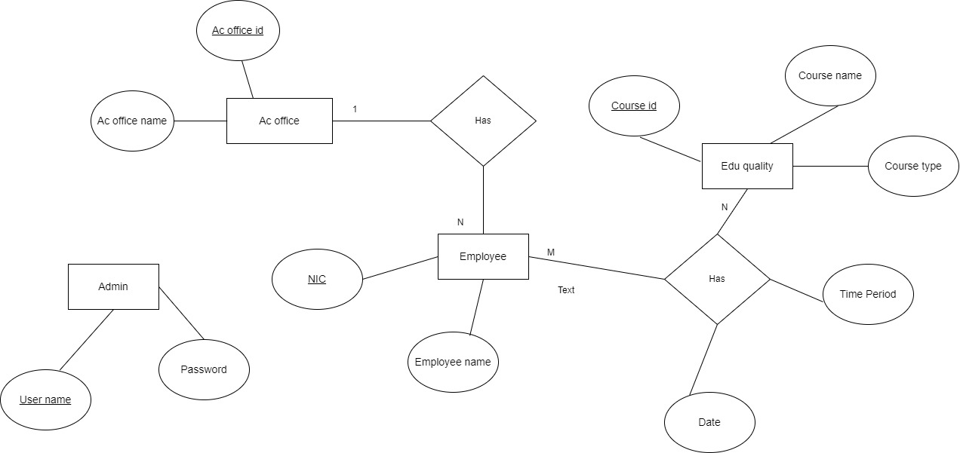

**6.2 Use Case Diagram**

